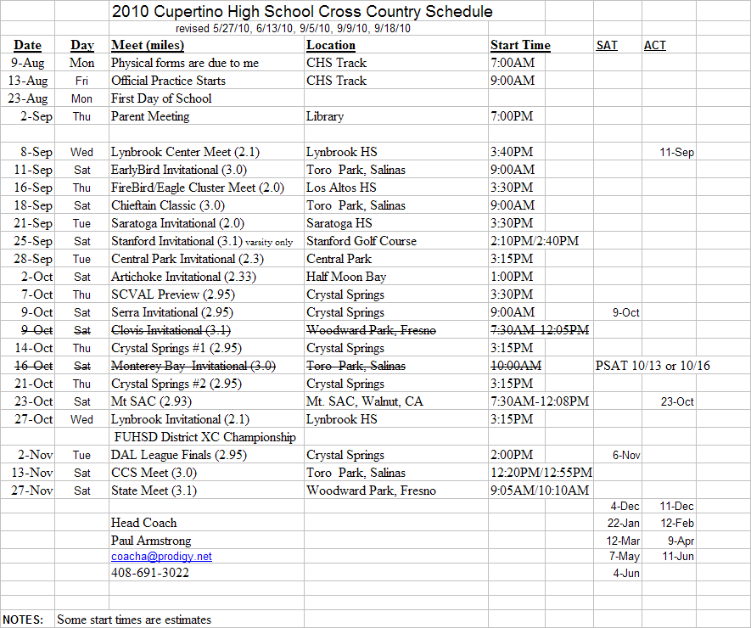

2010 Season Notes
1. All meets are required, except the Clovis and Mt.SAC.
2. All practices are required, including Saturday
3. Do not wait to get your physical done.
4. You must have a proper pair of running shoes throughout the season.
5. You must have warm-up pants.
6. Schedule tests (SAT & ACT) around the meets. The PSAT will be problematic.

